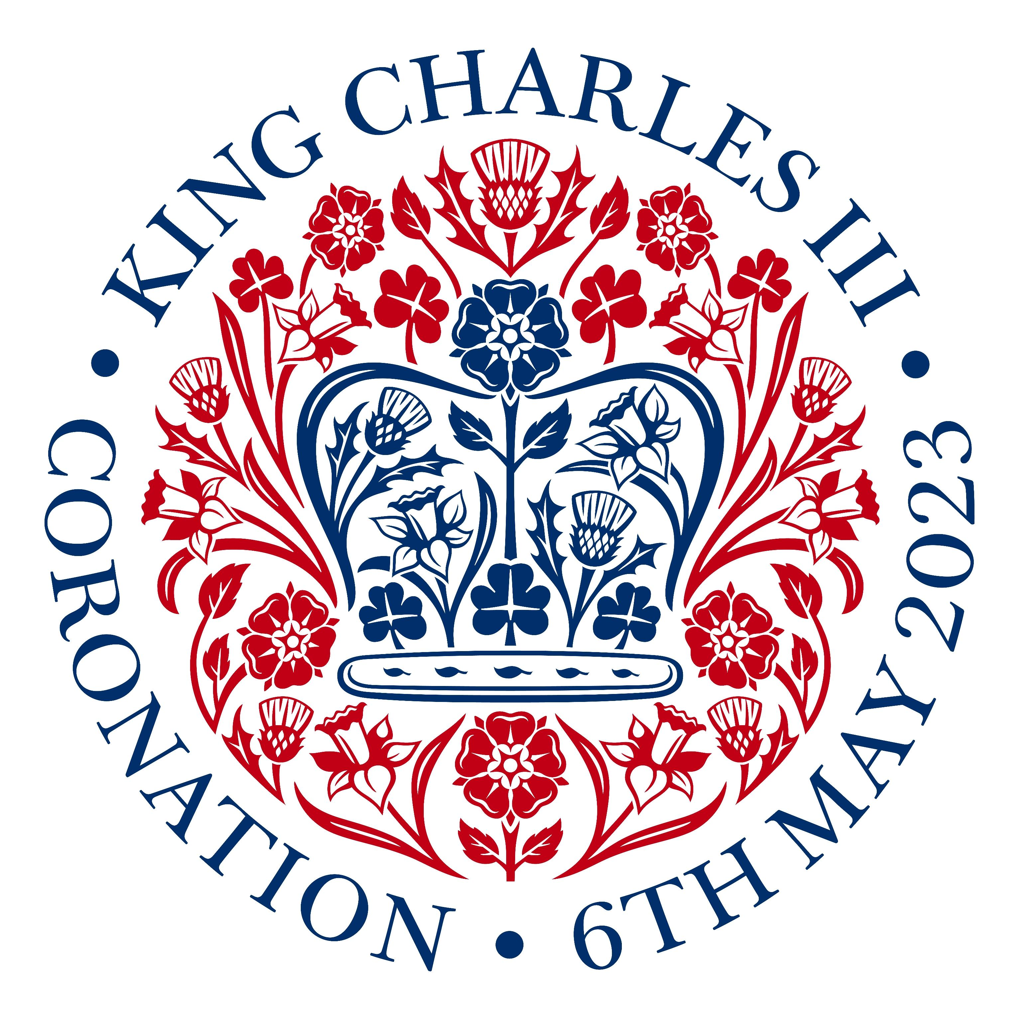
BAKING COMPETITION ENTRY FORM
Please complete one entry form for each cake you want to be judged

Name of Entrant

Type of cake
Age category (please circle) | Young child / Teen (13 – 17) / Adult
Contact detail (for contacting for any prizes) | Telephone Number | E mail address
Allergens – please list all allergens that may be present

Declarations:

I am happy for photos of my cake to be used in publicity material | Yes | No
I have read the guidelines of the competition and agree to them (parent or guardian to complete if entry is for child or teen category). | Enter you name here:

You should complete all sections of this form and submit it with your cake entry on the day.

Thank You – and good luck

Competition rules

- Please make sure your cake entry has been submitted by 2:30pm on Sunday 7th May with completed entry form. All cakes should be delivered to the kitchen.
- Judging will take place between 3pm and 3:30pm once all entries have been received
- After judging all cakes will then be available to enjoy with your scones. A donation plate will be available with all proceeds going to the Air Ambulance
- All allergens must be mentioned on the entry form
- Winners will be announced at the Right Royal Tea Celebrations, if the winners aren’t in attendance, we will contact them after the event.

