NORTON LINDSEY - SCARECROW COMPETITION
Sunday 24th September 2023
GUIDELINES:
- All residents of Norton Lindsey are welcome to enter the scarecrow competition and entry is FREE!
- The theme this year is HELPING THE ENVIRONMENT. You can interpret this however you wish!
- There are no age categories, but the judges will take into consideration the ages of the makers.
- There aren’t any rules as to how you build your scarecrow, though we ask you please to:
  - include some straw somewhere – it wouldn’t be a scarecrow otherwise!
  - build from scratch (no commercial creations, pre-moulded face masks, tailors’ dummies or mannequins please)
  - reduce, re-use and recycle – wherever possible.

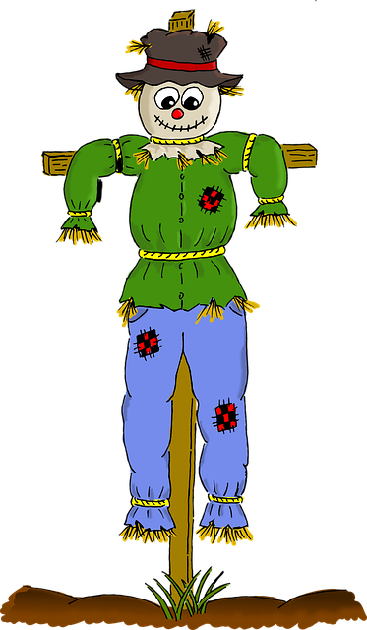

- Courtesy of Roger and John Mann at Littleworth Farm, a supply of straw will be available for collection from Friday 22nd September from the Village Hall car park.

- Judges will visit all scarecrows sometime between 10am and 6pm on Sunday 24th September. If your scarecrow is not on display when the judges come to look, it can’t be judged!
- Scarecrows should be displayed at the front of your property and easily visible by the Judges from the road. You should pin a card onto the scarecrow giving the NAMES AND AGES OF THOSE WHO MADE IT. Ages will be taken into consideration in the judging.
- Please ensure scarecrows are safely and securely fastened and cause no injury or danger to pedestrians nor curtail visibility for road traffic. They should be secured so that they will not blow away or cause annoyance to others.
- To have your scarecrow judged, you should complete an entry form, available on the Norton Lindsey Village Hall website www.nlvillagehall.org/events and SUBMIT IT TO eventsnlvh@gmail.com by NOON, SATURDAY 23rd SEPTEMBER.

- Winners will be announced on the Norton Lindsey Village Hall website.

The Norton Lindsey Village Hall CIO Trustees cannot be held responsible for any damage to Third Party property or people caused by the creation or insecurity of scarecrows. Owners are held solely responsible for the safety and security of their scarecrow.

